ACOSTA, HANZ ADRIEL P. CPEPRO18L

ENGR. DIANA L. JIMENEZ LAB. ACTIVITY NO. 6

LAB. ACTIVITY NO. 6

CONVOLUTION & CORRELATION OF DISCRETE- TIME SIGNALS

OBJECTIVES:

1. TO STUDY CONVOLUTION AND CORRELATION OF DISCRETE-TIME SIGNALS.

2. TO LEARN HOW TO IMPLEMENT THE TWO OPERATIONS USING MATHLAB.

INTRODUCTION:
Before this lab, I only knew convolution and correlation as formulas. After working through MATLAB, I realized that convolution actually blends two signals, while correlation checks how similar they are. These two operations may look similar, but they serve different purposes in signal processing.

III. MATERIALS & METHODS:
* MATLAB
MATLAB is a software that I use mainly for solving math and engineering problems. Instead of calculating everything manually, I just write commands and MATLAB gives the results instantly. It’s very useful for plotting signals, doing convolution, correlation, and other signal processing tasks. For me, it feels like a calculator but way more powerful because it can handle entire sequences and graphs with just one line of code.

ACOSTA, HANZ ADRIEL P. CPEPRO18L

ENGR. DIANA L. JIMENEZ LAB. ACTIVITY NO. 6

IV. RESULT:

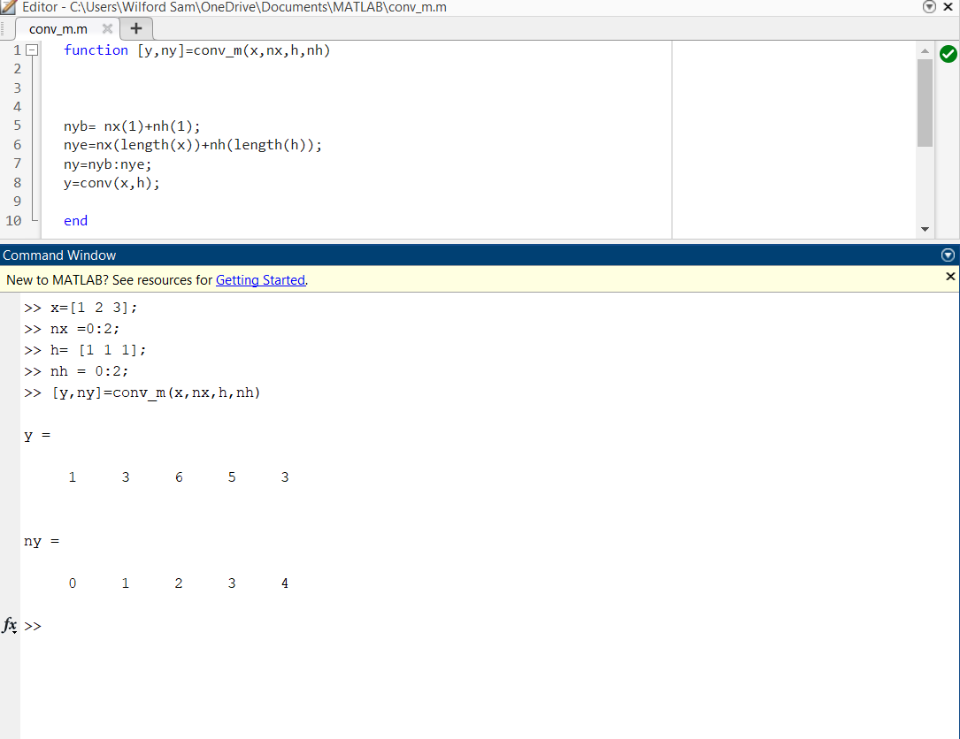

GROUP 1

MEMBERS:

DADACAY, ANGELYN
DIONSON , JAYSON R.

MANGAHAS , JHON CARL SYMON V.
LAYUG , NIÑO SHANE H.
CAYABYAB, CHRISTIAN AXEL D.
ACOSTA , HANZ ADRIEL P.
USON , JONATHAN R.
REYNA , MARY JANE

ACOSTA, HANZ ADRIEL P. CPEPRO18L

ENGR. DIANA L. JIMENEZ LAB. ACTIVITY NO. 6

V. DISCUSSION:
Convolution felt more like a signal transformation, while correlation acted like a similarity detector. Even though the commands in MATLAB were simple, the behavior of the outputs clearly showed their unique roles. This made me understand why convolution is used in filters, while correlation is used in detection.
VI. CONCLUSION:
Doing the lab myself helped me distinguish between the two operations more clearly. Convolution combines signals, while correlation compares them. MATLAB made the concepts easier to visualize and understand.
VII. REFERENCES:
• MathWorks. “conv - Convolution of Two Vectors.” MATLAB Documentation.
https://www.mathworks.com/help/matlab/ref/conv.html
• MathWorks. “xcorr - Cross-Correlation.” MATLAB Signal Processing Toolbox Documentation.
https://www.mathworks.com/help/signal/ref/xcorr.html

